Minutes
NSW Public Libraries Document Delivery Meeting
4th December 2024 – 2PM – Zoom / Macquarie Room, NSW State Library

Welcome and introductions

I acknowledge the Gadigal people of the Eora Nation, the traditional custodians of our local area and we acknowledge their continued connection to Country. I would like to pay respect to Elders both past and present and extend that respect to all Aboriginal and Torres Strait Islander people who are present.

Apologies

Sharon Downie, Liverpool; Aurora L’Aimable, Bayside; Alice Wong Riley, Woollahra; Murray Boothman, Strathfield, Huong Tran Lane Cove

Confirmation of August 2024 Minutes – Kris (Sutherland) Dianne (Hornsby)

Actions arising from previous meeting

- Metro Van issues – discussion with Cameron Morely (SLNSW).

  - SLNSW aware of ongoing Metro Vann issues
  - Shelley and Anne met with Cameron and Geneveive to discuss state of current contract and what could be done to improve service. Issues raised were:
    - Lack of set Van schedule. Driver arrives at any time, sometimes missing opening hours and allocated days altogether
    - Potential movement back to split run, North/South etc., as this has worked in past
    - Lack of notification of driver absence from Australia Post – leads to staff awaiting a delivery that isn’t coming.

  - Holding Australia Post accountable has proved difficult as SLNSW does need the information in real time but is receiving it a week or so later. Even when information does come through quickly getting a response from Australia Post has also proved difficult.

  - Proposal to review of current situation and look at alternate service delivery. Draft survey to be circulated from Cameron to get an idea of what works for the 29 Metro Libraries and how best to manage the run.
Review
    - Is courier the best option? Australia Post Driver currently fitting in other work as well as Van run
    - CFO Phil also included to see if SLNSW could take on a casual driver themselves. Financially would this be more beneficial? Currently sitting at $2,000 a day for 12 month contract
    - Previously Aust Post driver was inducted at SLNSW but now seems to be subcontracted by Aust Post and not seen much at SLNSW.
    - Geography – Are there locations that should be on the same day?
Look at previous maps from other runs. Noted that North and South Run did work well and that there was a relief person was also available for sick calls
Data collection
    - Think about how would the Van run work best for you - How many days a week. What times work for you? Is extra access to building needed?
    - If possible start collecting some sample data on how many items are sent and received at your Library via Van run.
    - How many items are sent/received by post vs Van?
  - Richmond Tweed example – send to the SLNSW and then SLNSW send out which works for regional
  - Question: We were assuming that the problem was area too big for one person? Noted that driver may also be fitting in other jobs so not solely on Metro Van run. This could explain some of the late runs and shouldn’t be happening.

  - Suggestion: work into any new tenders that smoking around the books not allowed.

  - Actions: Cameron to complete survey Draft to send out Thurs – Monday to see if everything is covered then formalized in the New Year.

  - Action: Metro Libraries to think about what they need out of the Van delivery and potentially have a sample of incoming and outgoing items to aid SLNSW in their decisions.

Multicultural Services report - Multicultural services report-2024-12.pdf

  - Multicultural bulk loan service closure for the 2024 holidays (email 4 December 2024)

    - The Multicultural bulk loan service will be suspended from 18th Dec 2024 to 1st Jan 2025 for the holiday season.

    - Tuesday, 10th Dec 2024 is the closing date for last orders that we will fulfil in 2024. Any orders received after 10th Dec 2024 will be fulfilled in 2025.

    - We will send out orders until Tuesday, 17th Dec 2024.

    - Libraries can still return your loans to the State Library during our shut down period.

  - Automatic Overdue reminders will be activate in the New Year. Will be sent from library@sl.nsw.gov.au
    - 9 months max for bulk loans ONLY if there is enough in stock
    - Email renewals preferred over online renewal by individual libraries
    - Email team for more accurate lost, loans, overdues lists while new system is settling in.

New log-in procedure for SLNSW
This is only relevant to libraries that have existing log in accounts for the SLNSW catalogue to check the status of your inter-library and bulk loans. Action: If unsure of your Libraries login check- in with Joanna in 2025.

Q: What is the current cost of lost bulk loan items? A: $49.50 inclusive of GST

  - Some Libraries require a PO for invoice – please let Joanna know if you need PO when reporting a lost item

Q: Can a Library add a new login? E.g. Can both collections and ILL have separate logins?
A: Yes. Two email addresses – must be unique email addresses
Note: 2025 ETA on new logins as system is working out problems.

ILL Van

  - Holiday van schedule: Make sure to send closure dates to Genevieve ASAP.
Q: How have the new Metro Van labels been going, have many locations been using the new template? A: Going well, yes certainly a big uptake to new format and hopefully less items going to wrong places.
  - Inner West did receive Blacktown’s box in error but whole tub so labels wouldn’t have helped.

Trove Collaborative Services Updates

  - Email sent Monday 2nd December to library managers to sign up to new platform by Friday 13th December. Action: If you haven’t seen this form check in with your Managers as the form would have gone to the main contact on the Trove Collaborative Services Contract (In NSPL’s case this was Collections Team Leader)
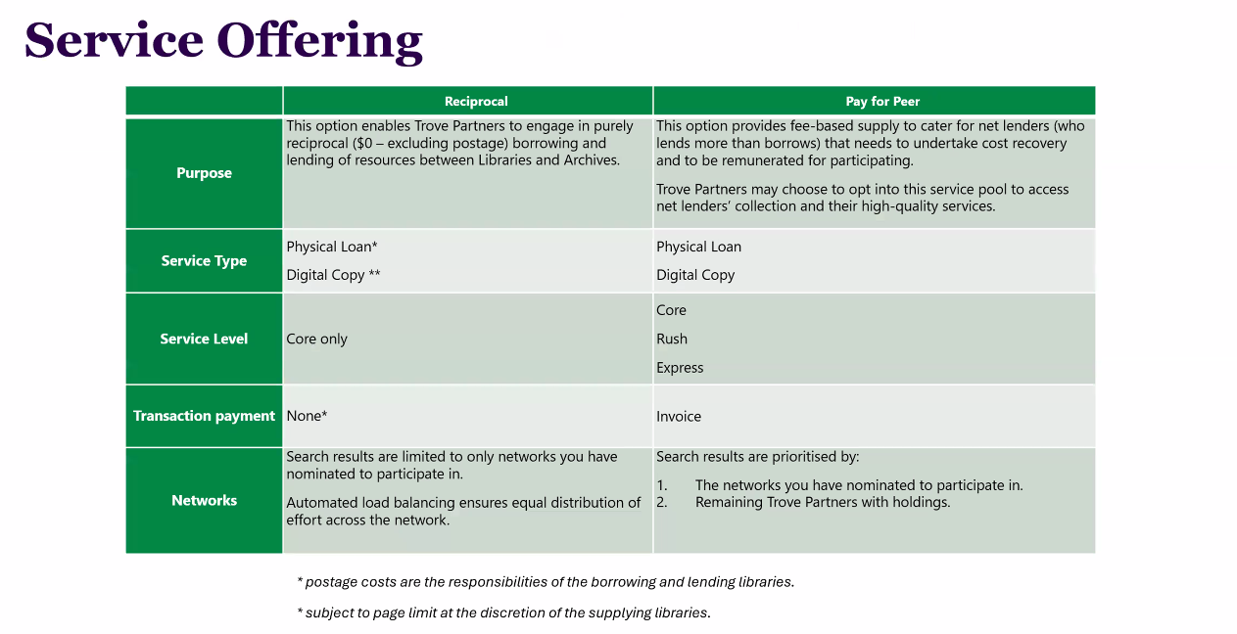
  - Trove Webinar held on Thurs 28/11 covering where changeover is at. Recording will be available through Trove Partners Learning Hub. Som key points also shown below:

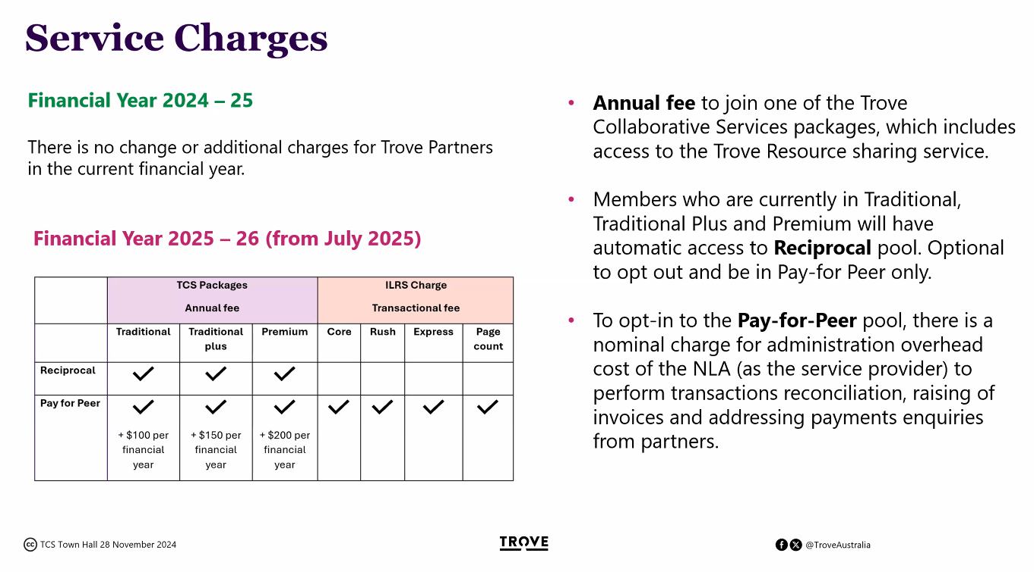
  - LADD VDX will run in tandem with ReShare from Mid-April with LADD VDX closing completely end of June 2025. Action: Potential freeze on new requests from Mid-May but will confirm with project team at NLA.
  - Next steps: Next Resource Sharing Working Group will meeting on Dec 12 2024. At the moment this should be around training but will update when we know more.
  - Q: What packages are other libraries on? A: NSPL is on Traditional currently bit of a price jump to Traditional plus.
  - Q: Hawkesbury – Is there a way to request reserve? A: unsure at this time. Workflow seems to be you search Libraries Australia –> comes up with a request –> Button to submit request that will open form in ReShare ReShare will auto allocate rota based on Tiers and availability.
Action: Check-in on option to reserve or edit form before sending out to locations in ReShare.
  - Can you chose charging from end of the Rota? A: To have access to charging locations you will need to be in the Pay for Peer tier. This is the ReShare equivalent of the current charging locations. No indication currently of what locations will be where – estimated release in 2025.
    - There is no limit to how many networks you can join but locations need to be in the same tiers as you to supply and lend. Has been discussed that once reciprocal options exhausted you will get a notification, like end of rota, before moving to the Pay for Peer.
  - Diane – Loads of Uni requests incoming over outgoing
  - Q: Can you offer to scan Index page of non -loanable item? A: There should be a separation of Document Delivery and ILL within ReShare. Action: Shelley to ask in next RSWG meeting.
  - Holdings Problem – Georges Rivers still showing deleted items after removal from LMS – Action: check in with OAIPMH as there may be issues with the sync between Libraries Australia holdings and the local LMS.

The Wiki

  - Join Partner Learning Hub

Libraries Australia/LADD issues
  - ALIA: ILL and classified material: Back in September ALIA received a notification that an ILL request was made for a classified publication. While the request was caught before being supplied it has prompted ALIA to reach out and make sure we are all checking our own ILL processes in terms of content classification and restricted items.
While Library collections are largely exempt from classification we all need to be aware of the current legislation around classification categories and how they apply to the InterLibrary loans service. (Copy of email below)
Interlibrary loans
We have received notification that someone has made an ILL request for a classified publication. This was luckily caught before the item was supplied, but it’s a good reminder for all to check that classification is now being included into the ILL processes. This is especially important in Qld, where Qld public libraries should have procedures in place to ensure that RC 18+ items are not able to be requested as these must not be brought into Qld for supply to patrons. This may be as simple as having a list of the common RC items (the Boys, American Psycho) in the process until we can get a little further on the consistent metadata front.
We have spoken to the ALIA resource sharing group and they are updating their training and guidance, and we have also reached out to NLA.
Current titles with a Category 1 Restricted rating
  - American Psycho by Bret Easton Ellis
  - The Boys (graphic novel) by Garth Ennis (Volumes 1,3,5)
  - Next steps:
  - Check in with your collections team. Back in 2023 our Collections TL ran a discussion in the collections WG to see what libraries were doing in terms of classification.
  - Look at your own local processes. Do you hold Category 1 or 2 items? Are they flagged in your catalogue? What processes are in place to catch any requests that may come through before the item is sent?
  - A section has been added to the Doku Wiki highlighting Resource Sharing and Classifications with links ratings information. Such as the National Classification Scheme.
  - what do ratings mean
  - how a rating is decided.
  - SLNSW – adds Category 1 restricted item sticker ; catalogue note on classification
  - Can be sent but requesting library needs to make sure it doesn’t go to anyone under 18 –
e.g. Ukrainian American Psycho

Suggested topics for discussion
  - Ania: Due dates on items. Please pay attention to the due date on items being sent out e.g. 23rd December no time to send back to the lending Library.
Noted in discussion that due dates are varied between Councils and States with some ILL officers unable to override the due dates set by Library managers and/or LMS at time of loan. As always please reach out to local library and ask for extension if needed

General business

Next meetings:

2025
Monday 3rd February 2025, 2-5pm (Hybrid meeting; both in person at the NSW State Library and online)
Monday 5 May 2025 2-5pm (Online) Monday 4th August 2025, 2-5pm (Online)
Monday 1st December 2025, 2-5pm (Hybrid meeting; both in person at the NSW State Library and online)

Attendees:

Maria, Canterbury Bankstown
Fujing, Ku-Rin-Gai
Eidell, Inner West
Mark, Ryde
Ponnary, Inner West
Kristin, Sutherland
Georgia, Hawkesbury
Teresita, Waverley
Diane, Hornsby
Deborah, Stanton
Cameron, SLNSW
Shelley, Cumberland
Anne, City of Sydney
Ania, Campbelltown
Ita, Tamworth
Tonia,
Li Yuan, Inner West
Deanne, Central Coast
Melanie,
Kalyani, Ku-ring-gai
Annie, Georges River
Ann, Camden
Christine, Blacktown
Joanna, SLNSW
Monica, Northern Beaches

