Requesting a book on LADD help tips

Login
Login to LADD (Libraries Australia Document Delivery) at http://docdel.librariesaustralia.nla.gov.au/  Barcode:  Password:  Click on Login | 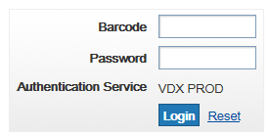
Search
Click on SEARCH  Find the correct item by searching by title, author, ISBN, format, publisher etc  Tip: Search the Libraries Australia database before requesting on LADD.  Type the RECORD ID number from the Libraries Australia record into the LOCAL NUMBER field  Searching Libraries Australia Help Sheet  Click on SEARCH | 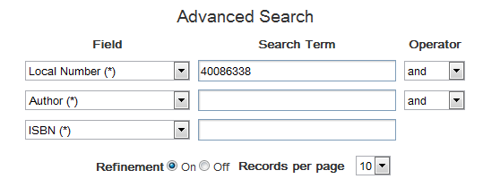
Find the correct item  Click on REQUEST | 
Request
Request Details  Authorisation Status: To be Authorised  Item Format: Book | 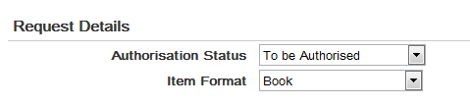
Service Details

Service Type: Loan

Item Details  This information should be automatically entered here  Note: Check that the details are correct and that you are requesting the correct title  Tip: Check Edition, ISBN, publishing details to request the correct title. | 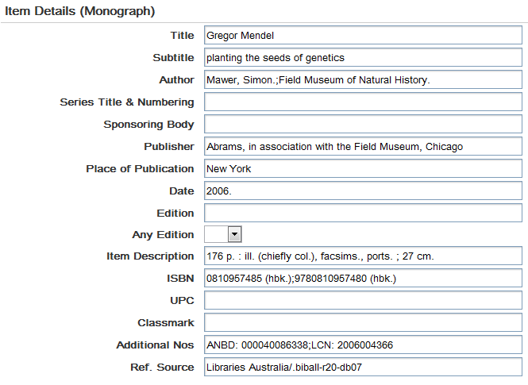
Rota Details  Highlight the NUC symbol of the library and click on ADD (this will place the library in the SELECTED rota box)  ADD Libraries to the SELECTED box and move the library up and down the rota, by clicking on UP or DOWN.  Tip: Place libraries that have the item available on the shelf at the top of the rota. Check for availability by searching in Libraries Australia, click on GET THIS ITEM and SEARCH CATALOGUE  Visit the Searching Libraries Australia Help Sheet for more information  Tip: Order of preference is:  - Metropolitan NSW public libraries (excluding NAML, NBNY, NMML, NSML & NKOG)  - NSW Public libraries  - Other non-charging public libraries  - NTSM (UTS Library) and  - NSL (State Library NSW) | 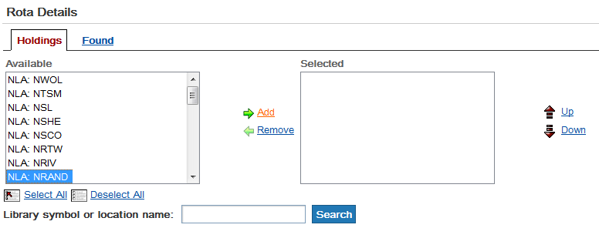  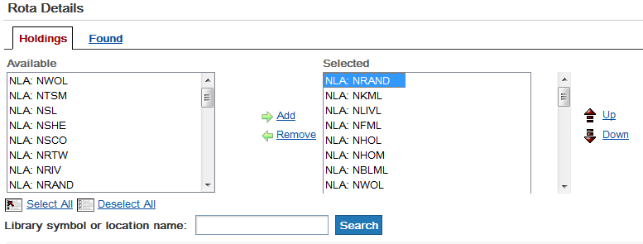
Notes  Add a private note if necessary.  This can only be viewed by your library. | 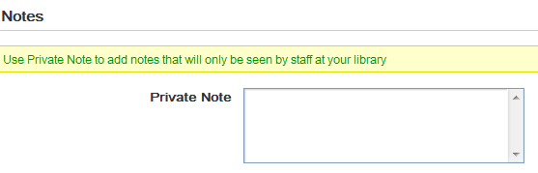
Patron Details  Patron Name: Patron name | 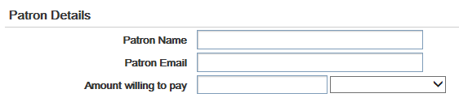
Additional Service Details  Service Level : CORE  Max. Cost: $0.00  Note: Maximum cost is $0.00, if borrower is only willing to pay $.......  Note: Maximum cost is $16.50, if borrower is willing to pay $16.50 for item. Borrower needs to be notified that there is a $16.50 charge before proceeding with ILL request. ILL form should also be signed and dated. | 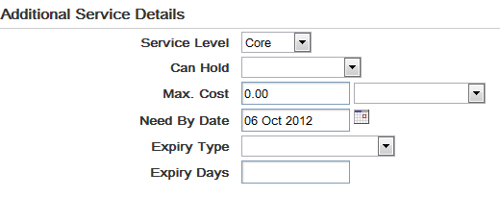
Delivery Details  Delivery Method: Postal Delivery  Click on REQUEST | 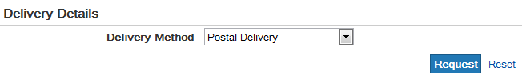
Write down ILL NUMBER on the paper Inter-Library Loan request form.

Send the form to the Inter-Library Loans Officer

Requesting a book on LADD

