NSW PUBLIC LIBRARIES DOCUMENT DELIVERY WORKING GROUP MEETING MINUTES
Date: Monday 1st August 2022
Venue: Online via Zoom
Time: 2.00pm – 5.00pm
Chairperson: Anne Laidlaw, City of Sydney & Shelley Petchell, Cumberland
Secretary: Anne Laidlaw, City of Sydney & Shelley Petchell, Cumberland

- Welcome and introductions
I acknowledge that I am hosting/recording this meeting from the lands of Gadigal People of the Eora Nation. I also acknowledge the Traditional Custodians of the various lands on which you all work today and the Aboriginal and Torres Strait Islander people participating in this meeting.

- Apologies
Kristin Ovidi, Sutherland; Diane Parkin, Hornsby
- Confirmation of minutes dated 1st May 2022.
Confirmed by Ken Cullen, Inner West & Parramatta attendees
- Actions arising from previous meeting
- Surveys sent to metro van run - completed. Surveys sent direct to Libraries on the Metro Van run on 6th May.

- ILL guidelines/training – This is ongoing progress area with not set training module available at the moment.

- LADD reverse charges – completed An updated link to the form needed for editing or reversing LADD charges has been added to the Doku Wiki here. Please note that the error has to be actioned by the supplying location so you may need to chase them up if you are the borrower.

- ILL Benchmarking survey – TO BE COMPLETED BY 31ST AUGUST As discussed in May meeting an ILL benchmarking survey has been sent to the ill@libraries elist by Thomas MacRae on Tuesday 26th July. This survey aimed at the ILL procedures/functions/technology across councils and also has a section to comment on the recent changes in Trove and LADD and how these will impact your Library. This survey is Due 31st August 2022 - Survey Monkey Link.
Note: If anyone can’t find this email or link to please let Anne know and she will forward to you if needed.

- State Library of NSW report
- No updates on catalogue training from Maria as yet. Will look at again towards end of the year.
- Great time to join the The PLS eNews – a monthly publication that gives a round up of events, promotions, and other activities of the State Library's Public Library Services branch. To subscribe, and to view past issues of the PLS eNews, see our website. Email also sent to PLN and managers elists on 27th July 2022.

- Multicultural Services report
- High demand for Ukrainian titles in both adult and junior collections. So while you may request a high number of titles, they may only send you a small amount so they can offer to other libraries still.
- Spanish Junior and German Junior titles are also in high demand with new orders on the way. Also working towards German titles being available on IndyReads and working with with a German teacher to achieve the best results. [Update] as of 5th September 200 German ebooks and eaudio is now available on the indyreads platform to be borrowed.
- While new title orders are in progress they are smaller orders and the current situation in Ukraine and Europe has had impact on arrival time.
- Refresh is underway for multicultural promotional material from SLNSW. If there are any types of promotional material that your would like to see in the future e.g. content for digital screens please let Abby know. Email sent Monday 1st August to multicultural working group.
- Trove Collaborative Services Updates
- Discuss Trove/LADD changes and what non-LADD methods currently used by Libraries.
- 2024 is the proposed phase out plan-less than three year transition.
- Trove Collaborative Services page now exists on ILL Doku Wiki (main page). When information comes through from the NLA on any proposed changes we will endeavour to add them in here. Currently it includes:
- Information on joining the Trove Collaborative Services elist for any information on upcoming webinars and wider updates. (here)
- Previous Webinars discussing LADD, including the last webinar on June 23rd that looked at current engagement strategy for ILL futures (19:14min). This webinar mentioned that the engagement strategy around LADD and resource sharing futures will be taking focus in July-Dec 2022. Stay tuned.

- Impacts of changes to LADD discussion
- The two big concerns around of the removal of LADD are the time required to complete ILL tasks and how to manage payments without assistance of bi-monthly invoices.

- Time required: Concern that requesting, tracking and returning each request via email will increase Admin load of the ILL officer. Without the ease of tracking requests in LADD how will be know who has what with the amount of emails received.
Asked how Libraries currently manage requests outside of LADD
  - Strathfield – Excel spreadsheet that tracks incoming and outgoing requests outside of LADD this is then also used for any stats that are needed.

  - Ryde – Without rota option uses folders to track requests. As there isn’t a large number of incoming requests this is manageable.

  - Woollahra – agreement with Waverley that Waverley have access to their account number and then reserve their own titles. Gives a bit of time back to Woolahra in terms of searching for items in catalogue.

  - Cumberland – Also has an excel spreadsheet to assist with statistics and tracking requests.

Discussion that excel seems to be a good means of tracking requests and might be worth setting up a basic spreadsheet now to see how it works for your library. We can revisit this in later meetings as more information comes to light.

Action: Murray has kindly shared some screenshots of his spreadsheet to assist in starting off.

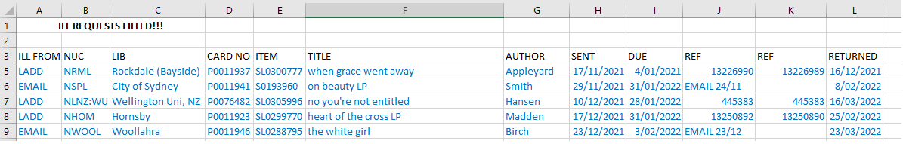
Requests from Libraries (external)

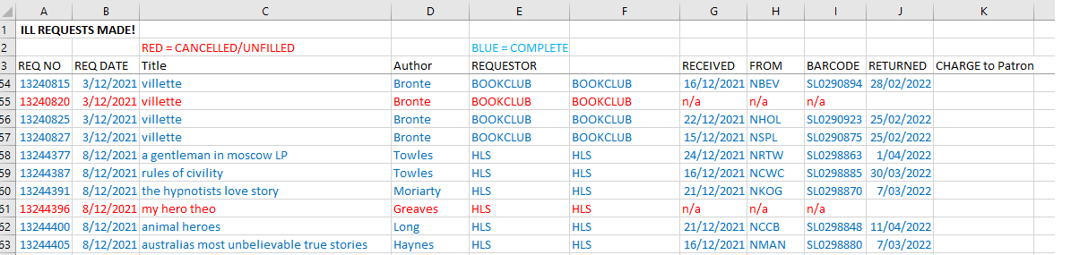
Requests from borrowers (internal)

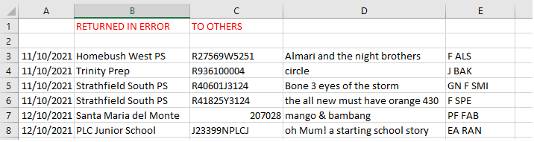
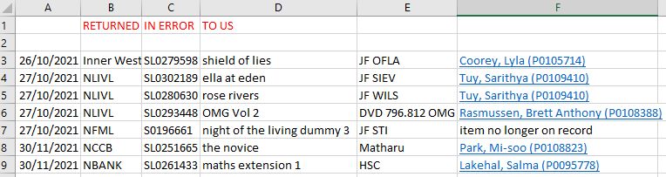
Returned in error

- Payments: Currently Libraries on LADD only have to pay Bi-monthly Invoices that catalogue charges and locations used. Without this the process of payments is going to be longer and harder to track through different areas of council and to know when it has been completed.

Statistics: Statistics is another area that data is pulled from LADD.
  - Canterbury-Bankstown has recently started collecting some internal stats on how many requests are through LADD and through Email to see where the majority lie.
  - City of Sydney has a monthly spreadsheet where incoming and outgoing numbers are tallied but not very detailed and still does rely on LADD.
  - Strathfield can pull their data from the existing spreadsheet that tracks their requests.

- Rep at Manager meetings: As there is a lot of information trickling down from managers meetings regarding Trove/LADD Abby suggested reaching out to a manager who could become our representative at higher level discussions, multicultural working group has one. Action: Potential to approach managers from benchmarking survey.

- How Libraries find Spydus as a management tool for ILL

  - Inner West – Spydus ILL module useful for requests as it can send outgoing requests straight to Libraries asking for the item. Also allows you to track request in the system and saves paper forms. Charging location payments made via invoicing.
  - Strathfield – outgoing requests much larger than incoming. Request module only used for internal requests (check)
  - Ryde – not having LADD rota means have a good folder system for what is coming from where. Ryde doesn’t deal with a high volume so it does work, e.g. No book club requests as they have their own Book Club Kits.
Invoicing for charging locations are done through Council’s finance/accounts department
- ILL Van
- Friday 22nd July email from Genevieve Freeman indicating new Van schedule for FY22/23 will be sent in August. Had been an end date of Fri 29th July to submit any alterations to current schedule.
Any delayed changes will affect the billing to your Library for Van Run cost in this FY22/23.
- The Wiki

- Libraries Australia/LADD issues
- New charges implemented on 1st July: No problems yet reported. It was noted that the increasing cost of charging locations has had a significant impact on number of requests to Universities etc.
- University Community borrower memberships – In a resent search around the University of Sydney website Anne discovered a community membership option starting at 3 months membership for $40 which then allows the public to borrow 10 items. Given that one loan is currently $30.30 it is worth looking into direct casual membership to Universities if you have borrowers to request from there a bit. USYD information available here: https://www.library.sydney.edu.au/libraries/membership.html
Dianne at Newcastle Library also let us know, the Newcastle University Library has a $100, 12 month casual public card.
- Suggested topics for discussion
- ILL replacement charges – Fujing once request for payment send through to other Library/Council generally do not have access to when bills are paid and resolved by other Councils to mark off issue solved on our end.
This was a similar situation for others and agreement that best way to remedy is to keep contact between ILL officers open as much as possible via email or LADD notes to update when Invoice sent to Finance team etc.

- Reply-all to eLists – ongoing issue. SLNSW is aware and currently looking into compiling issues people have been having and look at alternatives. Action: Anne to send through compilation of reminders and issues resulting from reply-all on elists

- Next meetings: Wednesday 7th December onsite at SLNSW Dixon meeting room, 2pm.

Attendees (18)
Teresita Quinones, Waverley
Abby Dawson, SLNSW
Anne Laidlaw, City of Sydney
Christine Bendit, Blacktown
Li Yuan Shepherd, Inner West
Helen Williams, Inner West
Ken Cullen, Inner West
Alice Wong Riley, Woollahra
Mayer Wu, Canterbury-Bankstown
Renea McLachlan, Canterbury-Bankstown
Shelley Petchell, Cumberland
Murray Boothman, Strathfield
Sharon Downie, Liverpool
Annie Persijn, Georges River Libraries
Georgia Matthews, Hawkesbury
Mark Ross, Ryde
Dianne Jenkins, Newcastle
Deanne Kennedy, Central Coast
Fujing Zhao, Ku-ring-gai
Annie Persjian, Georges River Libraries
Kaylani Ku-ring-gai

