Agenda
NSW Public Libraries Document Delivery Meeting
04 05 2026 – 2PM: Online via Zoom

1. Welcome and Introductions
I acknowledge that I am hosting this meeting from the lands of the Gadigal of the Eora Nation the traditional custodians of our local area. I pay my respects to Elders past, present and emerging, and recognise and celebrate the diversity of Aboriginal peoples and their ongoing cultures and connections to the lands and waters of NSW.
I also acknowledge the Traditional Custodians of the various lands on which you all work today and the Aboriginal and Torres Strait Islander people participating in this meeting.

2. Apologies
Julie, Canada Bay ; Kristin, Sutherland ; Suzanne, Richmond Upper Clarence ; Georgia, Hawkesbury ; Mandy, Albury ; Dianne, Newcastle ; Sharon, Liverpool ; Genevieve, SLNSW

3. Confirmation of February Minutes

4. ILL Van
- Update from Cameron

5. Actions arising from previous meeting
- Table of Reciprocal Universities on Doku Wiki: Hold off due to network review.
- Work group terms of reference

6. Multicultural Services report

7. Reshare/Trove Partners Issues and updates
Trove Partners Resource Sharing Network Review Webinars
- Webinars now on Doku Wiki – Resources for Trove Partners Resource Sharing
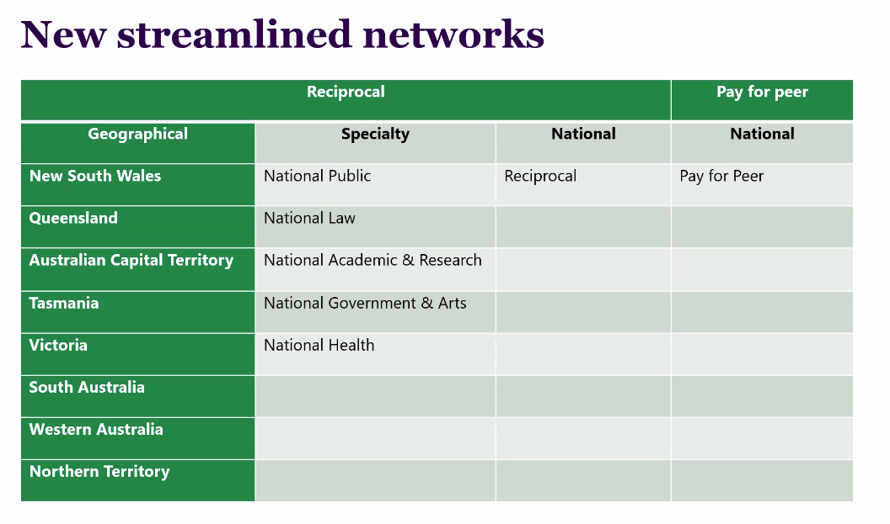
- New streamlined Networks
- Will be allocated locations based on Organisation and Location
- Default selection will be Geographical, Speciality then National (Reciprocal) then National Pay for Peer (if in both tiers)
- If you would like Speciality first then you can request this via form sent out on 29 April. Deadline 15 May.
- You will be able to re-prioritise which network is checked first if needs change.
- There is no option to control rota further than this within TPRS and requests cannot be sent to locations directly. Requests will still be allocated according to load balancing.
- All previous groupings will be invalid from 1 July 2026 with network options moving to Geographical, Speciality and National
- All institutions in the Reciprocal tier will be required to be a part of the National network stream.
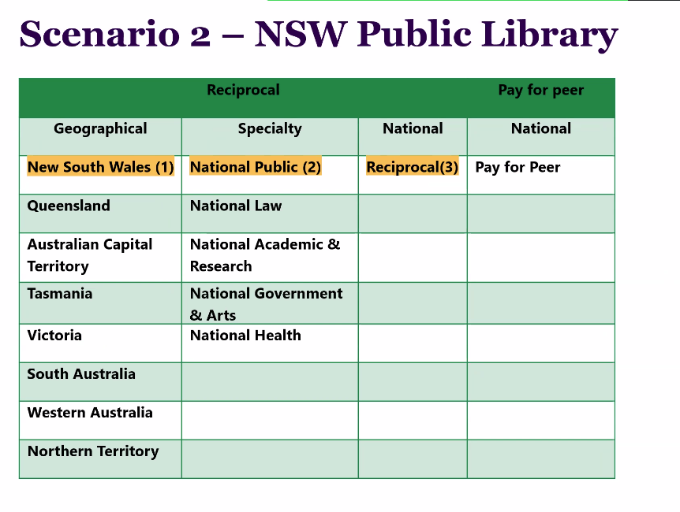

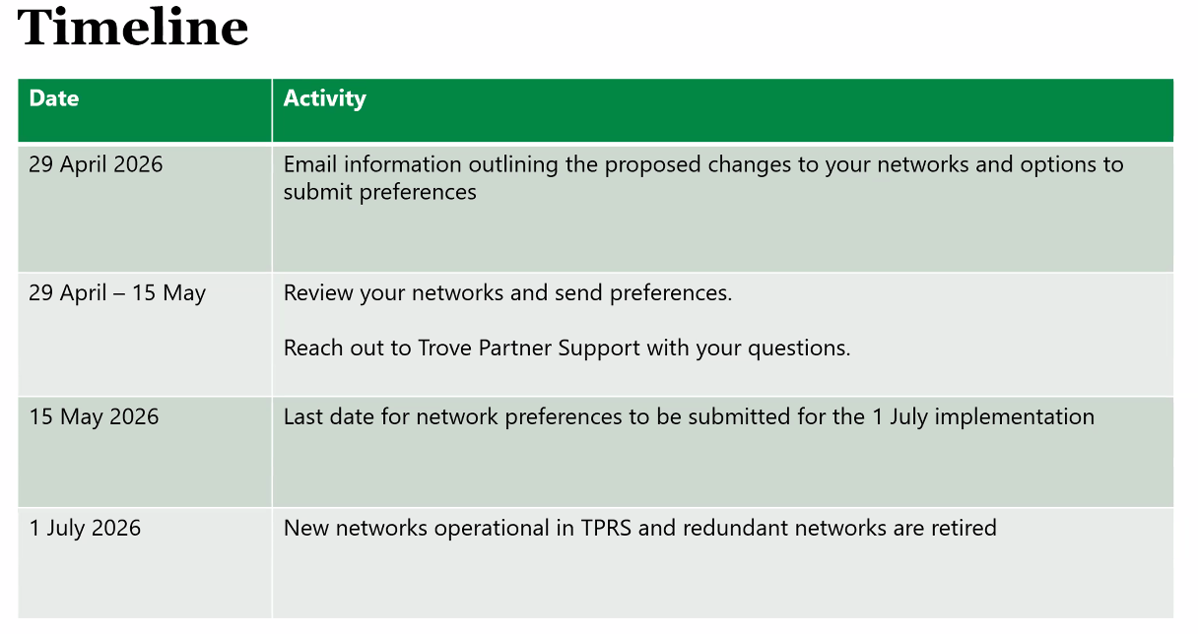

8. The Wiki
- Webinars added

9. Suggested topics for discussion
- TPRS Rota
- TPRS Network Review

10. General business
- Chair for working group

11. Next meetings:

2026
Monday 4th May: Online via Zoom
Monday 3rd August: Online via Zoom
Monday December 7th: Hybrid: In person at the NSW State Library (Jean Garling Room) and online via Zoom

Attendees:
Shelley Petchell, Cumberland
Ken Cullen, Inner West
Alison Owens, City of Canada Bay
Annie Chen, Stanton Library
Michael Smith, Waverley
Fiona Zi, Mosman Library
Joanna Goh, State Library of NSW
Alison Sandwith, Bega Valley
Alice Wong Riley, Woollahra
Parekh Chandra, Burwood
Deanne Kennedy, Central Coast
Christine Bendit, Blacktown
Jody Rodas, Woollahra Libraries
Li Yuan Shepherd, Inner West
Mark Ross, City of Ryde
Lisa Fisher, Maitland Libraries
Phillip Jones, Canada Bay
Parekh Chandra, Burwood
Aurora L'Aimable, Bayside
Diane Parkin, Hornsby
Alice Wong Riley, Woollahra
Murray Boothman, Strathfield
Fujing Zhao, Ku-ring-gai
Tonia Bartolozzi, Ku-Ring-Gai
Maria Castiglione, Canterbury-Bankstown
Cameron Morley, SLNSW
Anne Laidlaw, City of Sydney
Rebecca Kang Pliner, Waverley

