ANNUAL REPORT 2022
WORKING GROUP ON MULTICULTURAL LIBRARY SERVICES (NSW)
Introduction: The working Group on Multicultural Services, NSW role is to promote the library resources and services to wider multicultural community bringing together by sharing the collections and professional expertise and providing collective strength across all libraries in meeting the services needed by the CALD community.
During 2021-22, with continued restrictions and following health & safe protocols the Group held meeting via Zoom in March, May and September 2022.
Almost all public libraries experienced some period of building closure during the period, requiring libraries to adapt their services and delivery models to expand and moving programmes online. Librarians maintained the relationships with customers strengthening the role of public libraries during the crisis and beyond. Librarians were agile and adaptable, utilising the technology effectively in meeting the need of the community by providing home delivery services, conducting community welfare activities, online programs and providing the necessary support to access eResources. Access to library services was significant throughout the period of closures.
Multicultural Library Services Group at a glance 2021-22
The majority of the attendees at the meetings were multicultural library staff and the Working Group membership list represent 25 local councils.
- Chairperson: Sujatha Thadakamalla, Fairfield City Open Libraries
- Secretary: Jadwiga Krejza, Liverpool Library
- PLN Representative: Nicole Byrn
- State Library of NSW Representatives: Oriana Acevedo, Shauna Miller, Joanna Goh/Abby Dawson
We also had interesting presentations on the topics of interest to community:
- Staying well and preventing cancer
- Centre for Healthy Brain Ageing (CHeBA) UNSW
PROFILE OF WORKING GROUP
The working Group on Multicultural Services of NSW was established in June 1983 by several Librarians working in the field of library services for the CALD community. The Working Group’s role is to promote the provision of library resources and services to clients in a range of community languages.
VISION: Every NSW library will have access to an excellent resource collection and services that meet the needs of their CALD communities.
MISSION: To lobby, advice, promote, and improve the importance of library services for the CALD community.

Achievements, Changes and Activities
Multicultural Excellence Award:
From 2022 Individual award was a peered nominated award with multiple people to be able to be recognised to their contribution in enhancing the services to the CALD community
The multicultural Excellence Award for a library will continue to be managed as it has been with submission made along with the other awards at Switch Conference.
ALIA Multicultural Working Group: Oriana started the conversation with Trish and Mare Maticevski from RMIT who was looking at representation from different associations and the presented document was not very encouraging as the content did not apply to libraries.
On the 29/7/2022 we had preliminary meeting beginning the process, forming a group that is inclusive of people working in different areas, providing services to culturally and Linguistically Diverse Communities (CALD)
Further reporting was that ALIA will establish the Multicultural Working Group in November 2022 with an aim to cover all library staff including public, university and special libraries, with an ALIA webinar to launch the group. Members of the group submitted their feedback to Oriana on this initiative.
As some of you might have attended, ALIA Multicultural group was launched on November 22, 2022 and the special guest and speaker was Joseph Lo Bianco AM, Professor of Language and Literacy Education at the Melbourne Graduate School of Education, University of Melbourne. His presentation was very interesting and thought provoking to think on what we, as librarians could help in meeting the linguistic human rights and highlighted the challenges everyone faced around COVID 19, in meeting communication needs of the multicultural community.
We all have a role to play and should think on how we could contribute. Please respond to the ALIA Multicultural Consultation questionnaire and the consultation survey, links Oriana posted in her mail sent on November 22, 2022.
IFLA Multicultural Group: Oriana presented on the IFLA Multicultural Group. This IFLA Section works to promote best practice in delivering library services and collections to cultural and linguistic minorities. Oriana recommended that people join as members and get involved. For more information go to: https://www.ifla.org/units/mcultp/

Spotlight into multicultural services: Oriana planned and executed to put in place monthly online sessions highlighting different aspects of delivery of multicultural services by various libraries. The very importance of these sessions was to share the expertise with other colleagues and with long term multicultural staff leaving (retiring) it was felt these sessions will be a great opportunity to capture their knowledge.
Following sessions were held so far with active participation from number of librarians.
Blacktown Library
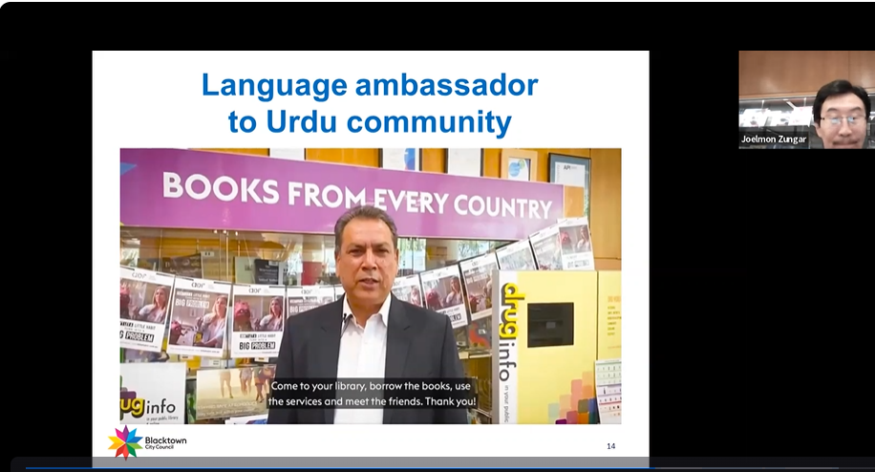

- 26 May: Liverpool Library
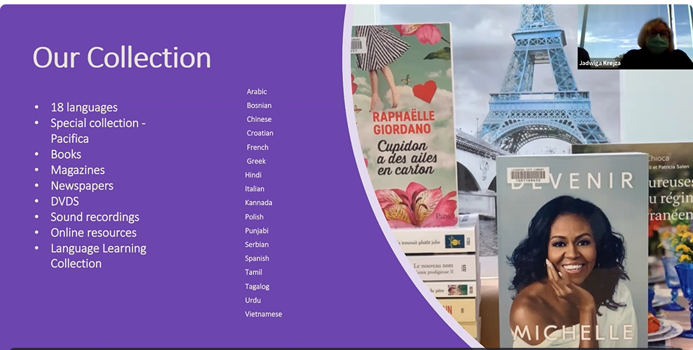

- 30 June: Canterbury-Bankstown Library
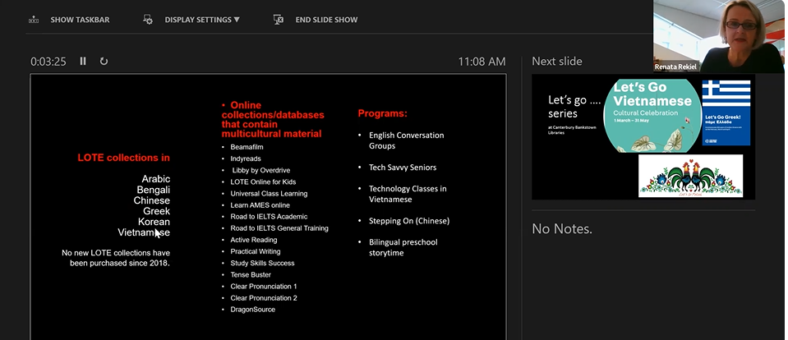
- 28 July: Parramatta Library
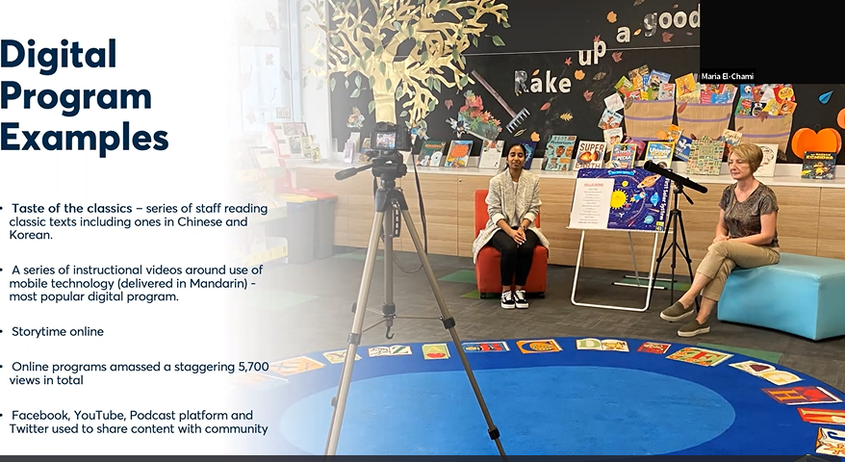

- 25 August: Fairfield City Open Libraries
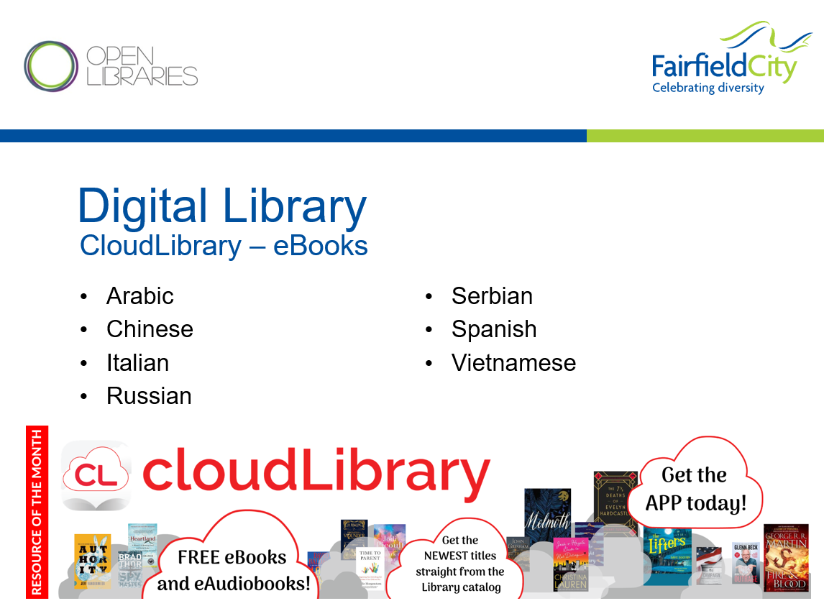
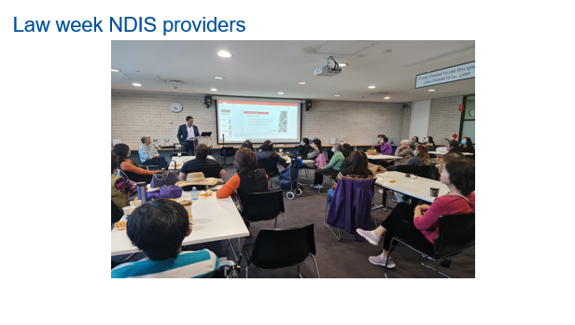
- 29 September – City of Ryde Libraries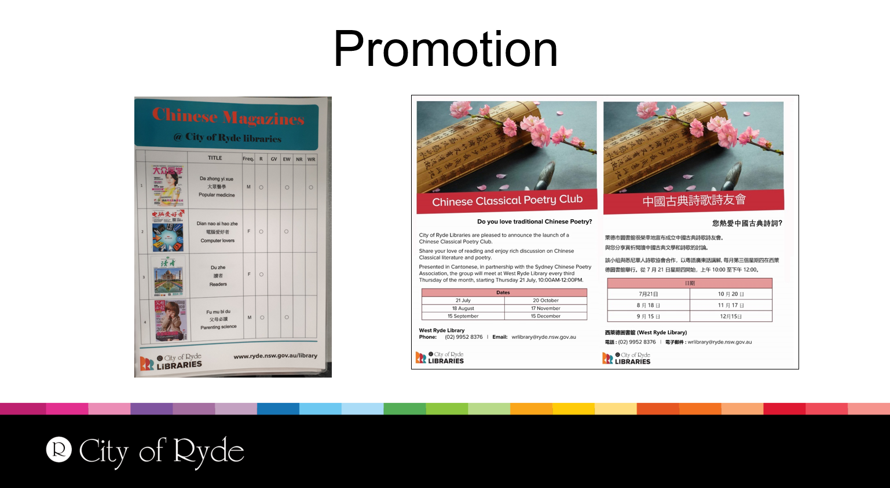
- 20 October: - Newcastle Libraries
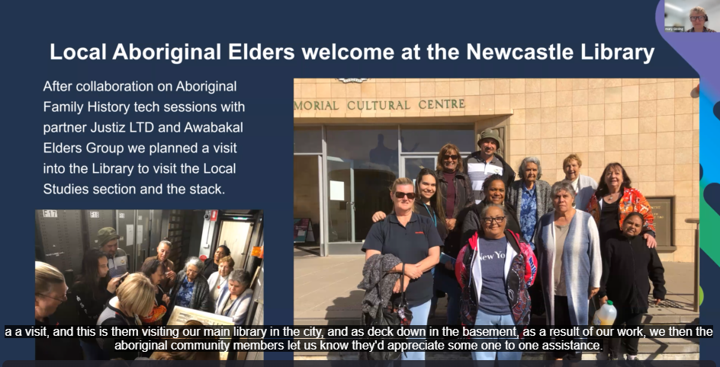

Culture and Core Inclusion - training: State Library New South Wales organised an online course by SBS to participate on Culture and Core Inclusion for members of the Multicultural group for participation. This Inclusion Program focused on improving understanding of diversity including LGBTIQ+, gender, age, disability, cultural diversity and Aboriginal and Torres Strait Islander peoples and cultures, with the aim of creating more inclusive workplaces and work practices.
2022 DCJ Inaugural Multicultural Community Engagement Conference 27 October 2022 – This conference was designed to focus on best practice and take on the learnings and experiences from the major life changing events including the COVID-19 pandemic, bushfires and flooding and the role service providers’ play while supporting multicultural communities. Members from State Library, Wollongong and Fairfield City Open Libraries attended the conference.
Multicultural Bulk Loans Service: State Library Bulk loan services is a huge support to meet the growing demand for LOTE collection from the community.
Multicultural Bulk Loan Service offered support to the libraries who were home delivering to their customers or offered ‘click and collect’ services with supply of language collection for multicultural community, During COVID pandemic.
Telugu Collection Launch: State Library under the leadership of Oriana had a great launch of the Telugu language collections at Blacktown Library and Cumberland Library. Sujatha Thadakamalla contributed in producing the Public Libraries language pamphlet – Telugu, interacting and building relationship with the Telugu community.
SLNSW – Marketing revamp: Abby is looking at the revamp of bookmarks and signage for Multicultural services by the State Library.
LOTE eContent on lending platforms:
Abby raised the discussion on LOTE eContent for lending looking for feedback.
Fairfield City Open Libraries (Sujatha presented) provides access to community language content eBooks through CloudLibrary platform and hoopla, streaming through Kanopy and hoopla. Fairfield has provided recently feedback to CloudLibrary Collection Development Manager on content development in different genre and non-fiction in LOTE languages. CloudLibrary expressed challenges in gaining publishers contract community language content.
Randwick Library (Katherine) Presented the challenges for Chinese languages, older users in using technology. Randwick subscribes to Russian collection on OverDrive.
City of Sydney (Sharlene) OverDrive provides feature to purchase what is popular. Staff are not involced in selection.
Fairfield City Libraries and City of Sydney were exploring Pay per use set up for customers to borrow titles of their interest in community languages. CloudLibrary platform expressed inability to introduce PPU program for LOTE collection due to publisher challenges with contracts.
Oriana suggested research and to look into funding on Digital resources.
Indyreads: The indyreads platform enables public libraries to provide free access to eBooks and eAudio. The collection continues to grow with over 23,169 eBook and Audio titles currently available. The LOTE collection includes 352 Chinese titles, 364 Italian, 414 Spanish titles, 272 French, 199 Romanian, 193 Russian, 191 Polish, 48 Vietnamese, 200 German and 256 Portuguese titles etc.,
indyreads Untapped the Australian Literary Heritage Project Collection: The Untapped collection contains over 160 culturally significant Australian titles that were previously out of print.
Tech Savy Seniors Multilingual Online training videos: A range of videos on topics such as smartphones, apps and Zoom meetings are available at Tech Savvy Seniors - YouTube. Languages currently covered are Arabic, Cantonese, Korean, Mandarin, Hindi, Spanish and Vietnamese.
Co-operative Purchasing
The co-operative purchasing has identified few more suppliers and offered material in Persian, Arabic, Spanish magazines, Russian, and Italian language print book collections.
SLNSW Research Projects
Diversity in children’s Picture Books in the multicultural collection was discussed and member of the group were invited to participate in the State Library survey.
Charles Sturt University – Collection usage during COVID 19 pandemic
Two public libraries participated with their lending data to analyse details of loans to understand the pattern of impact of COVID-19.
First language reading and public libraries - Exploring how reading in a person’s first language improves their sense of wellbeing, the project aimed to help inform on library collections in LOTE. Twelve participants from 11 language groups were interviewed and all participants expressed the importance of reading in their first language
Embracing the cultural identity of burgeoning ethnic groups in public libraries – a pilot project with the Punjabi Indian Community. This project explored the collection and services offered to the Punjabi Indian community in the Wagga Wagga area through an online survey.
Guest speakers @ working group 2022:
- Nikki Wolley, Cancer Institute NSW: Presentation included the resources available from Cancer Institute NSW. She provided URLs for Multicultural Community section that provides information for patients with resources in 8 community languages. https://www.cancer.nsw.gov.au/general-cancer-information/cancer-support/support-for-communities/multicultural-communities
Presentation also provided: Staying well and preventing cancer – flip chart in 15 languages https://www.cancer.nsw.gov.au/about-cancer/document-library/staying-well-and-preventing-cancer-community-educa
Breast screen flipchart. The Bowel screening flipchart, Cervical screening flipchart
- Zara Page – Centre for Healthy Brain Ageining (CHeBA) UNSW
Zara’s presentation was on the ongoing research on dementia and how the growth in number of Australian people with dementia was impacting on Australian Health system. CHeBA was looking at recruiting volunteers from CALD community to take part in the research.
Docuwiki
The Working Group has a presence on the State Library of NSW Website. Moving forward all Agenda and Minutes and relevant additional information for the group will be available only from the State Library of NSW Wiki.
https://wiki.libraries.nsw.gov.au/doku.php?id=minutes_multicultural

